**RTO MANAGEMENT**

**SYSTEM**

**SUBJECT: DATABASE MANAGEMENT SYSTEM**

**DHARAMSINH DESAI UNIVERSITY**

**FACULTY OF TECHNOLOGY, NADIAD**



**PREPARED BY:** **GUIDED BY**

HARSH SHAH (IT-102) PROF. R.M.RAVAL

DISHA SHAH (IT-101) (Assistant Prof.)

**INDEX**

1. Certificate………………………………

2. Acknowledgement………………………

3. System Overview……………

4. ER Diagram…………………………

5. Database Schema…………………………

4. Implementation………………………

* Create queries
* Insert queries
* Triggers

5. Other functionalities…………………………

6. Bibliography……………………………

**DHARAMSINH DESAI UNIVERSITY**

**DEPARTMENT OF INFORMATION TECHNOLOGY**



**CERTIFICATE**

This is to certify that **HARSH SHAH AND DISHA SHAH** student of Bachelor of Technology, Semester V (Information Technology) has completed her semester project work titled “**RTO MANAGEMENT SYSTEM**” in subject Database Management System satisfactorily in partial fulfillment of requirement during academic year 2017-2018.

**PROF. R.M. RAVAL PROF. R.S.Chajjed**

**(Assistant Prof.) (Head of dept.)**

**ACKNOWLEDGMENT**

On completion of project we would like to express our sincere thanks to all those who have guide, advised, inspired and supported during our project work.

Every work that one completes successfully stands on the constants encouragement, good will and support of the people around. We, hereby, avail this opportunity to express our heartfelt gratitude to a number of people who extended their valuable time, full support and cooperation in developing this project.

We are heartily thankful to the qualified staff of the center and especially to our lab faculty **Prof. R.M. Raval**. We believe that her computer expertise and valuable guidance have made it possible to present such nice project report.

Thanking you.

Yours Sincerely,

**HARSH SHAH (IT - 102)**

**DISHA SHAH (IT -101)**

**SYSTEM OVERVIEW**

This is a project based on **PL/SQL,MYSQL,PHP,HTML,CSS,JAVASCRIPT** language. In this, an online RTO management system runs. The database consists of data related to:

* All information about the users around the city.
* The info about the uses who have applied for learning and driving license, registration of motor vehicle, transfer of ownership, permit for vehicle.
* The user-friendly forms for the above as well as for the duplicates and renewals are easily available for each user.
* Also information about the authority in-charge and which authority gave approval to which specific application is accessible in the main database on the server.
* For benefit of the users the web portal is well designed and from the check status label one can easily get his/hers license, registration and permit number in case needed for renewal and stuff.

All updates done on data items are reflected on database. It contains Triggers for granting approval of the requested application.

**Advantages**

The whole system is online so all data about users and authority and the latest updates in the particular section are directly updated. All data related to users is available to government at any hour of the day. The tedious method of going through all the trouble of filling form and verifying it and then generating a unique id is gone, the user-friendly forms make it a lot easier.

The main aim is that all the data is centralized thus leading to faster, easier, correct and latest updated data access.

**ER DIAGRAM**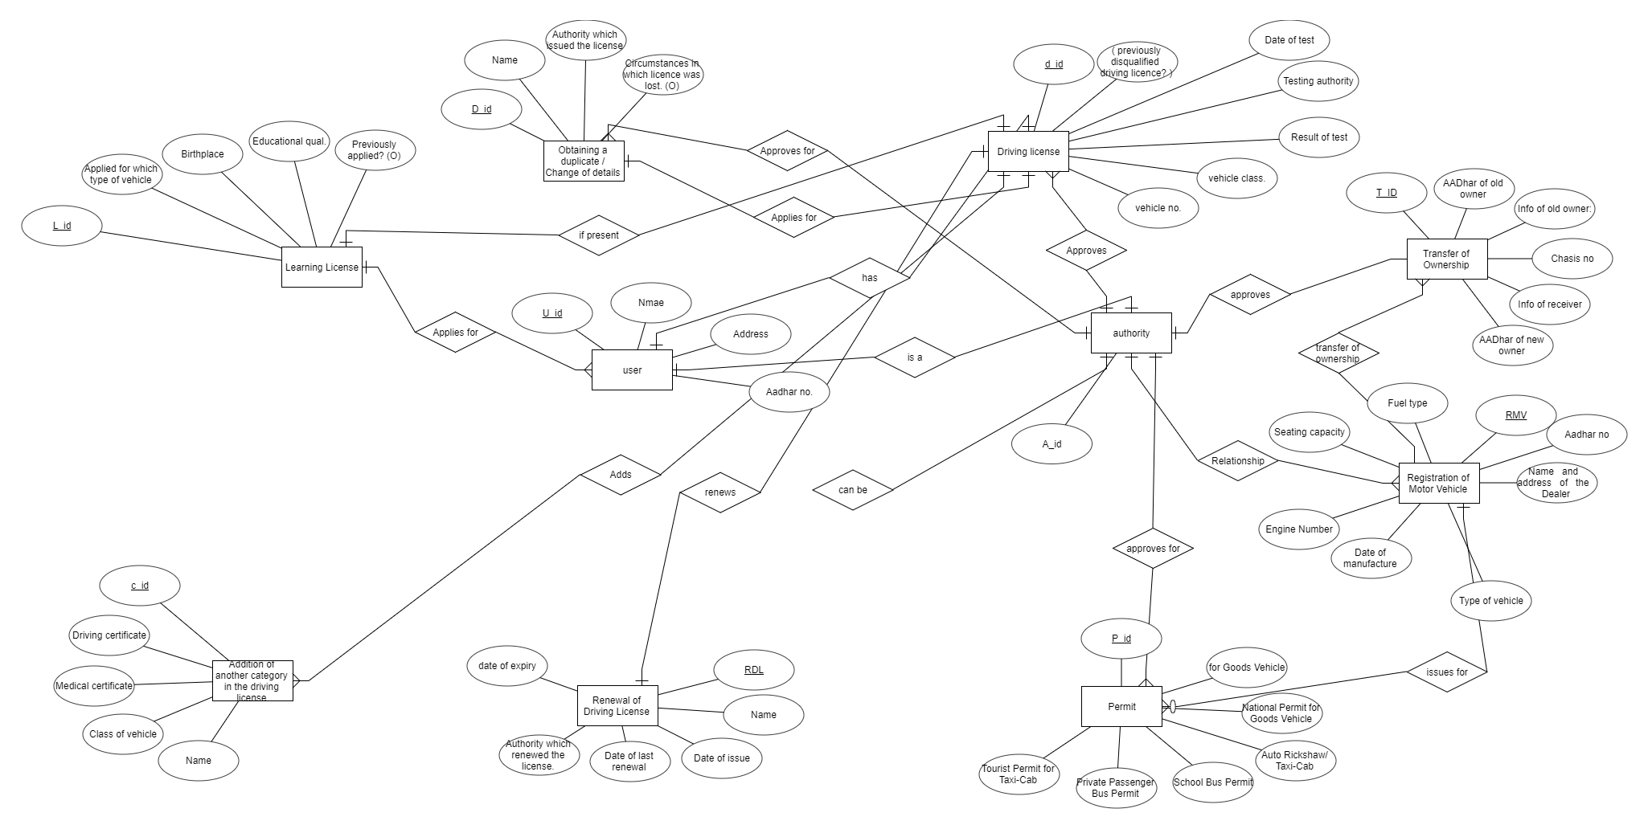

**DATABASE SCHEMA**

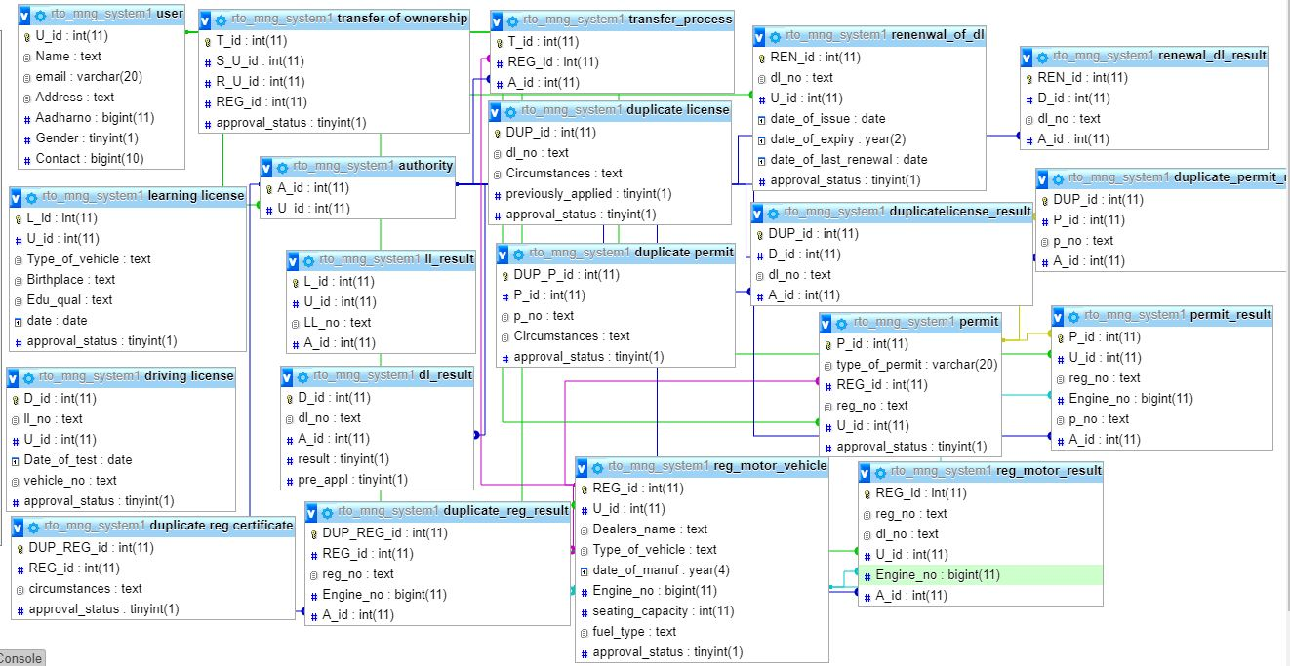

**IMPLEMENTATION**

*CREATE QUERIES*

-------------------------------------**FOR TABLE AUTHORITY** ------------------------------------

Table structure for table `authority`

CREATE TABLE `authority` (

`A_id` int(11) NOT NULL,

`U_id` int(11) NOT NULL

);

ALTER TABLE `authority` ADD PRIMARY KEY (`A_id`), ADD KEY `U_id` (`U_id`);

ALTER TABLE `authority` ADD CONSTRAINT `authority_ibfk_1` FOREIGN KEY (`U_id`) REFERENCES `user` (`U_id`);

----------------------------------------------------------------------------------------------------------------------------------

---------------------------------------**FOR TABLE LEARNING LICENSE**------------------------------------

CREATE TABLE `learning license` (

`L_id` int(11) NOT NULL, `U_id` int(11) NOT NULL,

`Type_of_vehicle` text NOT NULL, `Birthplace` text NOT NULL,

`Edu_qual` text NOT NULL, `date` date NOT NULL,

`approval_status` tinyint(1) NOT NULL DEFAULT '0'

);

ALTER TABLE `learning license` ADD PRIMARY KEY (`L_id`), ADD KEY `U_id` (`U_id`);

ALTER TABLE `learning license` ADD CONSTRAINT `learning license` FOREIGN KEY (`U_id`) REFERENCES `user` (`U_id`);

-----------------------------------------------------------------------------------------------------------------------------------

-----------------------------------------**FOR TABLE LL_RESULT**------------------------------------------------

CREATE TABLE `ll_result` (

`L_id` int(11) NOT NULL,

`U_id` int(11) NOT NULL,

`LL_no` text NOT NULL,

`A_id` int(11) NOT NULL

);

ALTER TABLE `ll_result`

ADD PRIMARY KEY (`L_id`);

-----------------------------------------------------------------------------------------------------------------------------------

--------------------------------------**FOR TABLE DRIVING LICENSE**-----------------------------------------

CREATE TABLE `driving license` (

`D_id` int(11) NOT NULL,

`ll_no` text NOT NULL,

`U_id` int(11) NOT NULL,

`Date_of_test` date NOT NULL,

`vehicle_no` text NOT NULL,

`approval_status` tinyint(1) NOT NULL

);

ALTER TABLE `driving license`

ADD PRIMARY KEY (`D_id`),

ADD KEY `U_id` (`U_id`),

ADD KEY `Date_of_test` (`Date_of_test`);

ALTER TABLE `driving license`

ADD CONSTRAINT `driving license_ibfk_2` FOREIGN KEY (`U_id`) REFERENCES `user` (`U_id`);

-----------------------------------------------------------------------------------------------------------------------------------

------------------------------------------**FOR TABLE DL_RESULT** ----------------------------------------------

CREATE TABLE `driving license` (

`D_id` int(11) NOT NULL,

`ll_no` text NOT NULL,

`U_id` int(11) NOT NULL,

`Date_of_test` date NOT NULL,

`vehicle_no` text NOT NULL,

`approval_status` tinyint(1) NOT NULL

);-

ALTER TABLE `driving license`

ADD PRIMARY KEY (`D_id`),

ADD KEY `U_id` (`U_id`),

ALTER TABLE `driving license`

ADD CONSTRAINT `driving license_ibfk_2` FOREIGN KEY (`U_id`) REFERENCES `user` (`U_id`);

----------------------------------------------------------------------------------------------------------------------------------

-------------------------------------------------**FOR TABLE PERMIT**-----------------------------------------------

Table structure for table `permit`

CREATE TABLE `permit` (

`P_id` int(11) NOT NULL,

`type_of_permit` varchar(20) NOT NULL,

`REG_id` int(11) NOT NULL,

`reg_no` text NOT NULL,

`U_id` int(11) NOT NULL,

`approval_status` tinyint(1) NOT NULL

);

ALTER TABLE `permit`

ADD PRIMARY KEY (`P_id`),

ADD KEY `REG_id` (`REG_id`),

ADD KEY `U_id` (`U_id`);

ALTER TABLE `permit`

ADD CONSTRAINT `permit_ibfk_1` FOREIGN KEY (`REG_id`) REFERENCES `reg_motor_vehicle` (`REG_id`),

ADD CONSTRAINT `permit_ibfk_2` FOREIGN KEY (`U_id`) REFERENCES `user` (`U_id`);

-----------------------------------------------------------------------------------------------------------------------------------

---------------------------------------**FOR TABLE PERMIT_RESULT**-----------------------------------------

CREATE TABLE `permit_result` (

`P_id` int(11) NOT NULL,

`U_id` int(11) NOT NULL,

`reg_no` text NOT NULL,

`Engine_no` bigint(11) NOT NULL,

`p_no` text NOT NULL,

`A_id` int(11) NOT NULL

);

ALTER TABLE `permit_result`

ADD PRIMARY KEY (`P_id`),

ADD KEY `U_id` (`U_id`),

ADD KEY `Engine_no` (`Engine_no`),

ADD KEY `A_id` (`A_id`);

ALTER TABLE `permit_result`

ADD CONSTRAINT `permit_result_ibfk_1` FOREIGN KEY (`U_id`) REFERENCES `user` (`U_id`),

ADD CONSTRAINT `permit_result_ibfk_2` FOREIGN KEY (`Engine_no`) REFERENCES `reg_motor_vehicle` (`Engine_no`),

ADD CONSTRAINT `permit_result_ibfk_3` FOREIGN KEY (`A_id`) REFERENCES `authority` (`A_id`),

ADD CONSTRAINT `permit_result_ibfk_4` FOREIGN KEY (`P_id`) REFERENCES `permit` (`P_id`);

-----------------------------------------------------------------------------------------------------------------------------------

--------------------------------**FOR TABLE REG_OF_MOTOR_VEHICLE**-------------------------------

CREATE TABLE `reg_motor_vehicle` (

`REG_id` int(11) NOT NULL,

`U_id` int(11) NOT NULL,

`Dealers_name` text NOT NULL,

`Type_of_vehicle` text NOT NULL,

`date_of_manuf` year(4) NOT NULL,

`Engine_no` bigint(11) NOT NULL,

`seating_capacity` int(11) NOT NULL,

`fuel_type` text NOT NULL,

`approval_status` tinyint(1) NOT NULL

)REFERENCES PRISONER1(PRISONER_ID) ON DELETE CASCADE ON UPDATE CASCADE

);

ALTER TABLE `reg_motor_vehicle`

ADD PRIMARY KEY (`REG_id`),

ADD KEY `U_id` (`U_id`),

ADD KEY `Engine_no` (`Engine_no`);

ALTER TABLE `reg_motor_vehicle`

ADD CONSTRAINT `reg_motor_vehicle_ibfk_1` FOREIGN KEY (`U_id`) REFERENCES `user` (`U_id`);

-----------------------------------------------------------------------------------------------------------------------------------

--------------------------------**FOR TABLE REG_MOTOR_RESULT**---------------------------------------

CREATE TABLE `reg_motor_result` (

`REG_id` int(11) NOT NULL,

`reg_no` text NOT NULL,

`dl_no` text NOT NULL,

`U_id` int(11) NOT NULL,

`Engine_no` bigint(11) NOT NULL,

`A_id` int(11) NOT NULL

);

ALTER TABLE `reg_motor_result`

ADD PRIMARY KEY (`REG_id`),

ADD KEY `U_id` (`U_id`),

ADD KEY `A_id` (`A_id`),

ADD KEY `Engine_no` (`Engine_no`);

ALTER TABLE `reg_motor_result`

ADD CONSTRAINT `reg_motor_result_ibfk_1` FOREIGN KEY (`U_id`) REFERENCES `user` (`U_id`),

ADD CONSTRAINT `reg_motor_result_ibfk_2` FOREIGN KEY (`A_id`) REFERENCES `authority` (`A_id`),

ADD CONSTRAINT `reg_motor_result_ibfk_3` FOREIGN KEY (`Engine_no`) REFERENCES `reg_motor_vehicle` (`Engine_no`);

-----------------------------------------------------------------------------------------------------------------------------------

------------------------------**FOR TABLE TRANSFER OF OWNERSHIP**--------------------------------

CREATE TABLE `transfer of ownership` (

`T_id` int(11) NOT NULL,

`S_U_id` int(11) NOT NULL,

`R_U_id` int(11) NOT NULL,

`REG_id` int(11) NOT NULL,

`approval_status` tinyint(1) NOT NULL

);

ALTER TABLE `transfer of ownership`

ADD PRIMARY KEY (`T_id`),

ADD KEY `S_U_id` (`S_U_id`),

ADD KEY `R_U_id` (`R_U_id`),

ADD KEY `REG_id` (`REG_id`);

ALTER TABLE `transfer of ownership`

ADD CONSTRAINT `transfer of ownership_ibfk_2` FOREIGN KEY (`S_U_id`) REFERENCES `user` (`U_id`),

ADD CONSTRAINT `transfer of ownership_ibfk_3` FOREIGN KEY (`R_U_id`) REFERENCES `user` (`U_id`),

ADD CONSTRAINT `transfer of ownership_ibfk_4` FOREIGN KEY (`REG_id`) REFERENCES `reg_motor_vehicle` (`REG_id`);

-----------------------------------------------------------------------------------------------------------------------------------

----------------------------------**FOR TABLE TRANSFER PROCESS**--------------------------------------

CREATE TABLE `transfer_process` (

`T_id` int(11) NOT NULL,

`REG_id` int(11) NOT NULL,

`A_id` int(11) NOT NULL

);

ALTER TABLE `transfer_process`

ADD PRIMARY KEY (`T_id`),

ADD KEY `REG_id` (`REG_id`),

ADD KEY `A_id` (`A_id`);

ALTER TABLE `transfer_process`

ADD CONSTRAINT `transfer_process_ibfk_1` FOREIGN KEY (`REG_id`) REFERENCES `reg_motor_vehicle` (`REG_id`),

ADD CONSTRAINT `transfer_process_ibfk_2` FOREIGN KEY (`A_id`) REFERENCES `authority` (`A_id`);

-----------------------------------------------------------------------------------------------------------------------------------

--------------------------**FOR TABLE RENEWAL OF DRIVING LICENSE**---------------------------

CREATE TABLE `renenwal_of_dl` (

`REN_id` int(11) NOT NULL,

`dl_no` text NOT NULL,

`U_id` int(11) NOT NULL,

`date_of_issue` date NOT NULL,

`date_of_expiry` year(2) DEFAULT NULL,

`date_of_last_renewal` date NOT NULL,

`approval_status` tinyint(1) NOT NULL

);

ALTER TABLE `renenwal_of_dl`

ADD PRIMARY KEY (`REN_id`),

ADD KEY `U_id` (`U_id`);

ALTER TABLE `renenwal_of_dl`

ADD CONSTRAINT `renenwal_of_dl_ibfk_2` FOREIGN KEY (`U_id`) REFERENCES `user` (`U_id`);

-----------------------------------------------------------------------------------------------------------------------------------

-------------------**FOR TABLE RENEWAL OF DRIVING LICENSE RESULT**--------------------

CREATE TABLE `renewal_dl_result` (

`REN_id` int(11) NOT NULL,

`D_id` int(11) NOT NULL,

`dl_no` text NOT NULL,

`A_id` int(11) NOT NULL

);

ALTER TABLE `renewal_dl_result`

ADD PRIMARY KEY (`REN_id`),

ADD KEY `D_id` (`D_id`),

ADD KEY `A_id` (`A_id`);

ALTER TABLE `renewal_dl_result`

ADD CONSTRAINT `renewal_dl_result_ibfk_1` FOREIGN KEY (`D_id`) REFERENCES `driving license` (`D_id`),

ADD CONSTRAINT `renewal_dl_result_ibfk_2` FOREIGN KEY (`A_id`) REFERENCES `authority` (`A_id`);

-----------------------------------------------------------------------------------------------------------------------------------

----------------------------------**FOR TABLE DUPLICATE LICENSE**---------------------------------------

CREATE TABLE `duplicate license` (

`DUP_id` int(11) NOT NULL,

`dl_no` text NOT NULL,

`Circumstances` text NOT NULL,

`previously_applied` tinyint(1) NOT NULL,

`approval_status` tinyint(1) NOT NULL

);

ALTER TABLE `duplicate license`

ADD PRIMARY KEY (`DUP_id`);

-----------------------------------------------------------------------------------------------------------------------------------

-----------------------------**FOR TABLE DUPLICATE LICENSE RESULT**-----------------------------

CREATE TABLE `duplicatelicense_result` (

`DUP_id` int(11) NOT NULL,

`D_id` int(11) NOT NULL,

`dl_no` text NOT NULL,

`A_id` int(11) NOT NULL

);

ALTER TABLE `duplicatelicense_result`

ADD PRIMARY KEY (`DUP_id`),

ADD KEY `A_id` (`A_id`),

ADD KEY `D_id` (`D_id`);

ALTER TABLE `duplicatelicense_result`

ADD CONSTRAINT `duplicatelicense_result_ibfk_1` FOREIGN KEY (`A_id`) REFERENCES `authority` (`A_id`),

ADD CONSTRAINT `duplicatelicense_result_ibfk_2` FOREIGN KEY (`D_id`) REFERENCES `driving license` (`D_id`);

-----------------------------------------------------------------------------------------------------------------------------------

----------------------------**FOR TABLE DUPLICATE REG CERTIFICATE**-----------------------------

CREATE TABLE `duplicate reg certificate` (

`DUP_REG_id` int(11) NOT NULL,

`REG_id` int(11) NOT NULL,

`circumstances` text NOT NULL,

`approval_status` tinyint(1) NOT NULL

);

ALTER TABLE `duplicate reg certificate`

ADD PRIMARY KEY (`DUP_REG_id`),

ADD KEY `REG_id` (`REG_id`);

ALTER TABLE `duplicate reg certificate`

ADD CONSTRAINT `duplicate reg certificate_ibfk_1` FOREIGN KEY (`REG_id`) REFERENCES `reg_motor_vehicle` (`REG_id`);

-----------------------------------------------------------------------------------------------------------------------------------

----------------------------**FOR TABLE DUPLICATE REG CERTIFICATE**-----------------------------

CREATE TABLE `duplicate_reg_result` (

`DUP_REG_id` int(11) NOT NULL,

`REG_id` int(11) NOT NULL,

`reg_no` text NOT NULL,

`Engine_no` bigint(11) NOT NULL,

`A_id` int(11) NOT NULL

);

ALTER TABLE `duplicate_reg_result`

ADD PRIMARY KEY (`DUP_REG_id`),

ADD KEY `REG_id` (`REG_id`),

ADD KEY `A_id` (`A_id`),

ADD KEY `Engine_no` (`Engine_no`);

ALTER TABLE `duplicate_reg_result`

ADD CONSTRAINT `duplicate_reg_result_ibfk_1` FOREIGN KEY (`REG_id`) REFERENCES `reg_motor_vehicle` (`REG_id`),

ADD CONSTRAINT `duplicate_reg_result_ibfk_2` FOREIGN KEY (`A_id`) REFERENCES `authority` (`A_id`),

ADD CONSTRAINT `duplicate_reg_result_ibfk_3` FOREIGN KEY (`Engine_no`) REFERENCES `reg_motor_vehicle` (`Engine_no`);

-----------------------------------------------------------------------------------------------------------------------------------

----------------------------**FOR TABLE DUPLICATE REG CERTIFICATE**-----------------------------

CREATE TABLE `duplicate_reg_result` (

`DUP_REG_id` int(11) NOT NULL,

`REG_id` int(11) NOT NULL,

`reg_no` text NOT NULL,

`Engine_no` bigint(11) NOT NULL,

`A_id` int(11) NOT NULL

);

ALTER TABLE `duplicate_reg_result`

ADD PRIMARY KEY (`DUP_REG_id`),

ADD KEY `REG_id` (`REG_id`),

ADD KEY `A_id` (`A_id`),

ALTER TABLE `duplicate_reg_result`

ADD CONSTRAINT `duplicate_reg_result_ibfk_1` FOREIGN KEY (`REG_id`) REFERENCES `reg_motor_vehicle` (`REG_id`),

ADD CONSTRAINT `duplicate_reg_result_ibfk_2` FOREIGN KEY (`A_id`) REFERENCES `authority` (`A_id`),

ADD CONSTRAINT `duplicate_reg_result_ibfk_3` FOREIGN KEY (`Engine_no`) REFERENCES `reg_motor_vehicle` (`Engine_no`);

-----------------------------------------------------------------------------------------------------------------------------------

-------------------------------------**FOR TABLE DUPLICATE PERMIT** --------------------------------------

CREATE TABLE `duplicate permit` (

`DUP_P_id` int(11) NOT NULL,

`P_id` int(11) NOT NULL,

`p_no` text NOT NULL,

`Circumstances` text NOT NULL,

`approval_status` tinyint(1) NOT NULL

);

ADD PRIMARY KEY (`DUP_P_id`),

ADD KEY `P_id` (`P_id`);

ALTER TABLE `duplicate permit`

ADD CONSTRAINT `duplicate permit_ibfk_1` FOREIGN KEY (`P_id`) REFERENCES `permit` (`P_id`);

-----------------------------------------------------------------------------------------------------------------------------------

---------------------------------------------------**FOR TABLE USER** ------------------------------------------------

CREATE TABLE `user` (

`U_id` int(11) NOT NULL,

`Name` text NOT NULL,

`email` varchar(20) NOT NULL,

`Address` text NOT NULL,

`Aadharno` bigint(11) NOT NULL,

`Gender` tinyint(1) NOT NULL,

`Contact` bigint(10) NOT NULL

);

ALTER TABLE `user`

ADD PRIMARY KEY (`U_id`);

-----------------------------------------------------------------------------------------------------------------------------------

*INSERT QUERIES*

-----------------------------------------------**FOR TABLE AUTHORITY**------------------------------------------

The Authority has his own password and logs in via Admin login and only the authority has the power to grant approval to a specific application of the user.

INSERT INTO `authority` (`A_id`, `U_id`) VALUES

(20, 1),

(18, 2),

(22, 3),

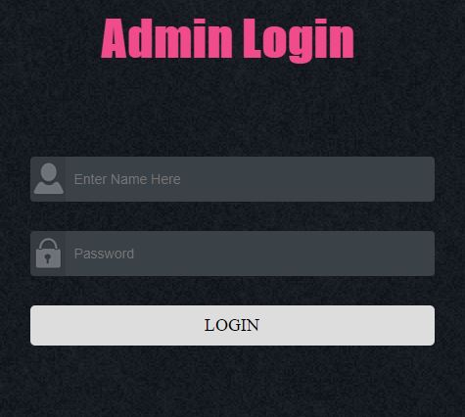

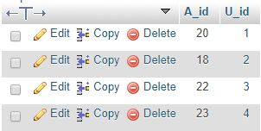

----------------------------------------------------------------------------------------------------------------------------------

---------------------------------------**FOR TABLE LEARNING LISENCE**------------------------------------

User, after signing up/logging in can fill the desired form and apply for the same.

INSERT INTO `learning license` (`L_id`, `U_id`, `Type_of_vehicle`, `Birthplace`, `Edu_qual`, `date`, `approval_status`) VALUES

(1, 1, '2', 'bhopal', '4', '2017-09-08', 1),

(2, 2, '2', 'surat', '3', '2017-10-02', 1),

(3, 3, '1', 'bharuch', '6', '2017-10-03', 1),

(4, 4, '1', 'baroda', '2', '2017-10-11', 1),

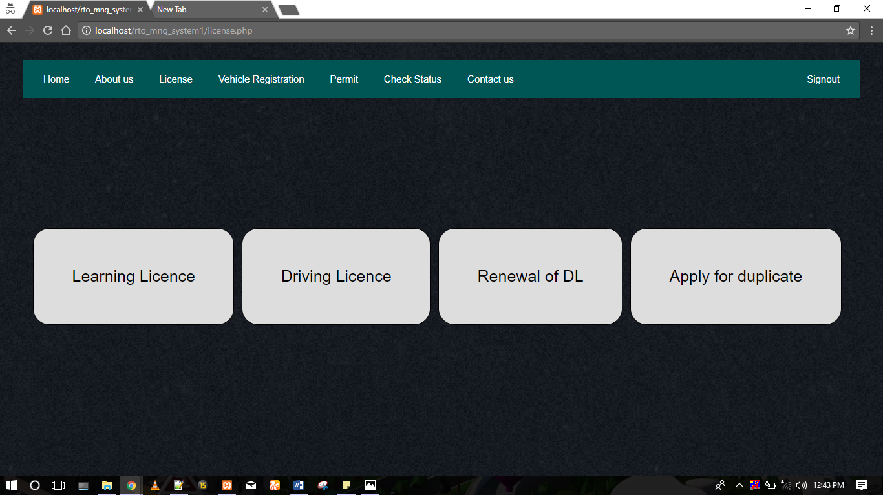

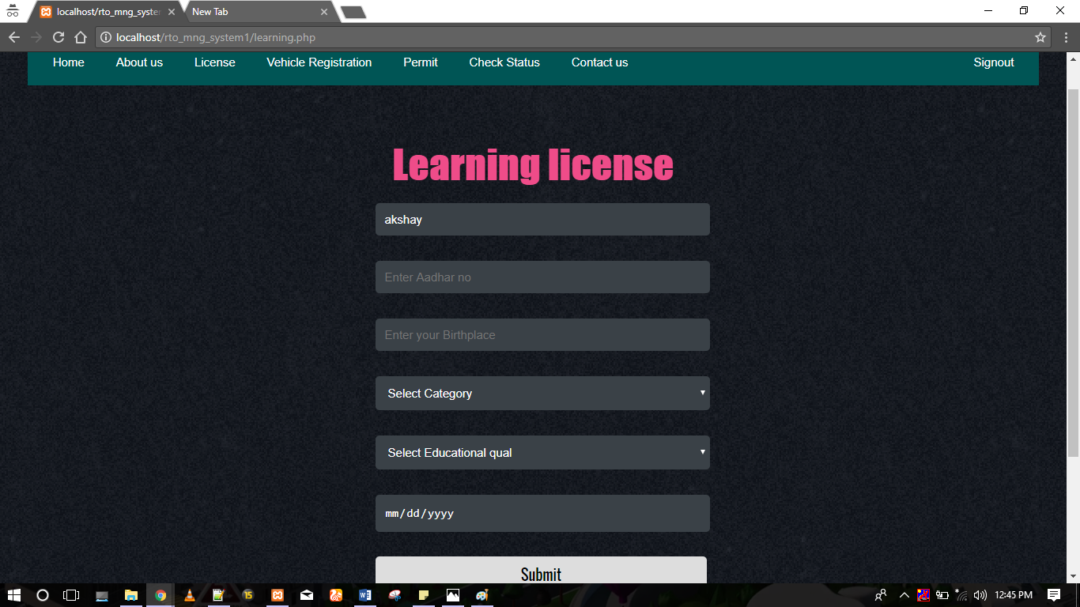

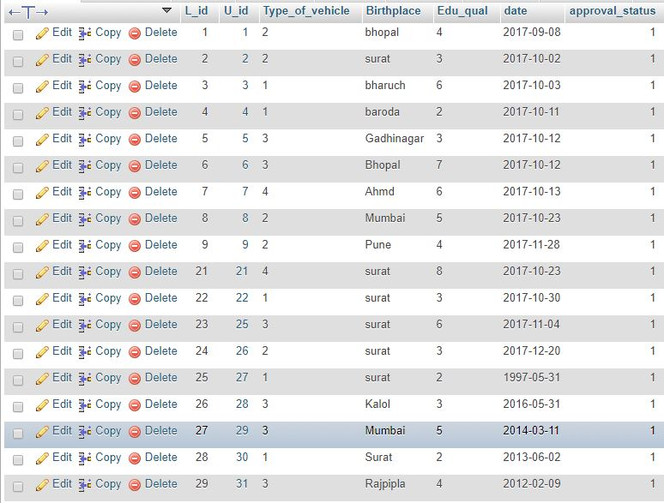

------------------------------------------------**FOR TABLE LL_RESULT**----------------------------------------

INSERT INTO `ll_result` (`L_id`, `U_id`, `LL_no`, `A_id`) VALUES

(1, 1, 'LL59f70d60c5a9b', 18),

(2, 2, 'LL59f5ea7as54e9', 20),

(3, 3, 'LLw785ea70ae2e', 20),

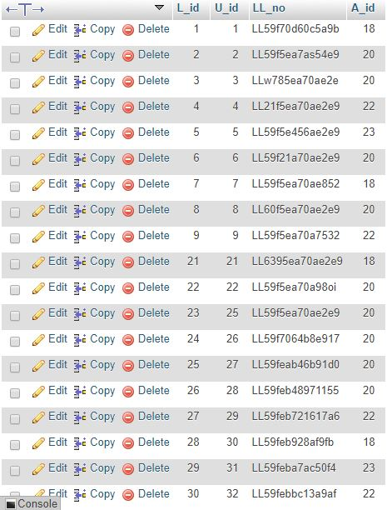

-----------------------------------------------------------------------------------------------------------------------------------

-------------------------------------------**FOR TABLE DRIVING LICENSE**------------------------------------

INSERT INTO `driving license` (`D_id`, `ll_no`, `U_id`, `Date_of_test`, `vehicle_no`, `approval_status`) VALUES

(1, 'LL59f70d60c5a9b', 1, '2016-05-09', '3654', 1),

(2, 'LL59f5ea7as54e9', 2, '2016-09-08', '6382', 1),

(3, 'LLw785ea70ae2e', 3, '2015-11-21', '8956', 1),

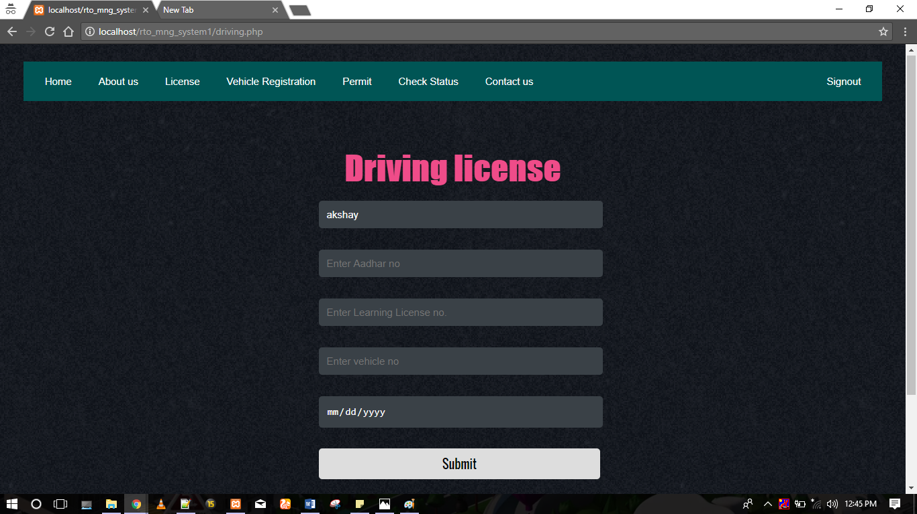

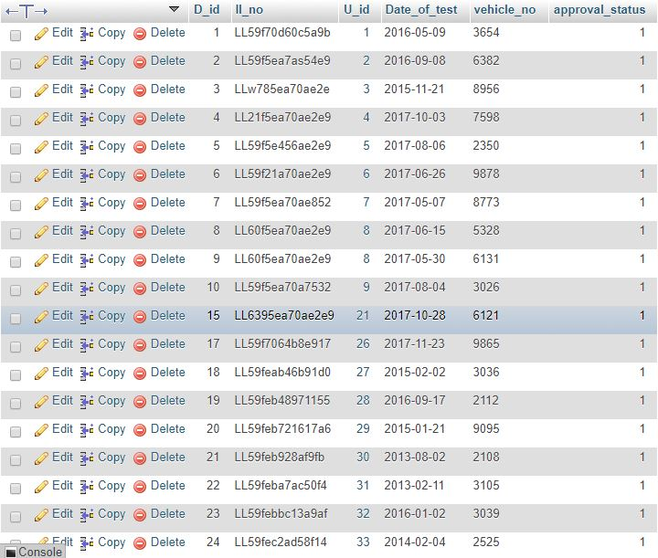

----------------------------------------------------------------------------------------------------------------------------------

------------------------------------------------**FOR TABLE DL_RESULT**-----------------------------------------

INSERT INTO `dl_result` (`D_id`, `dl_no`, `A_id`, `result`, `pre_appl`) VALUES

(1, 'DL59f7181618956', 23, 0, 0),

(2, 'DL59we45161fd9d', 22, 0, 0),

(3, 'DL56ty76161fd9d', 18, 0, 0),

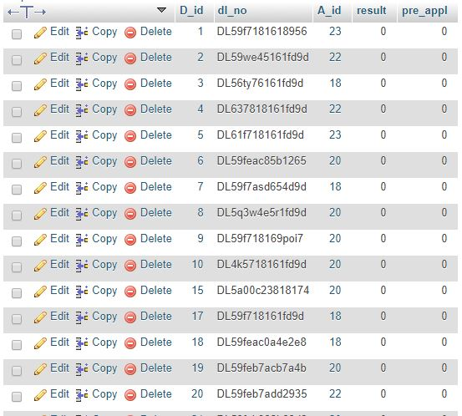

-----------------------------------------------------------------------------------------------------------------------------------

-------------------------**FOR TABLE REGISTRATION FOR MOTOR VEHICLE**-------------------

INSERT INTO `reg_motor_vehicle` (`REG_id`, `U_id`, `Dealers_name`, `Type_of_vehicle`, `date_of_manuf`, `Engine_no`, `seating_capacity`, `fuel_type`, `approval_status`) VALUES

(1, 2, 'Dream Honda', '4', 2016, 25634, 4, '4', 1),

(2, 3, 'Dream Yuva', '2', 2013, 85694, 4, '3', 1),

(3, 4, 'Dream Honda', '3', 2014, 47834, 2, '2', 1),

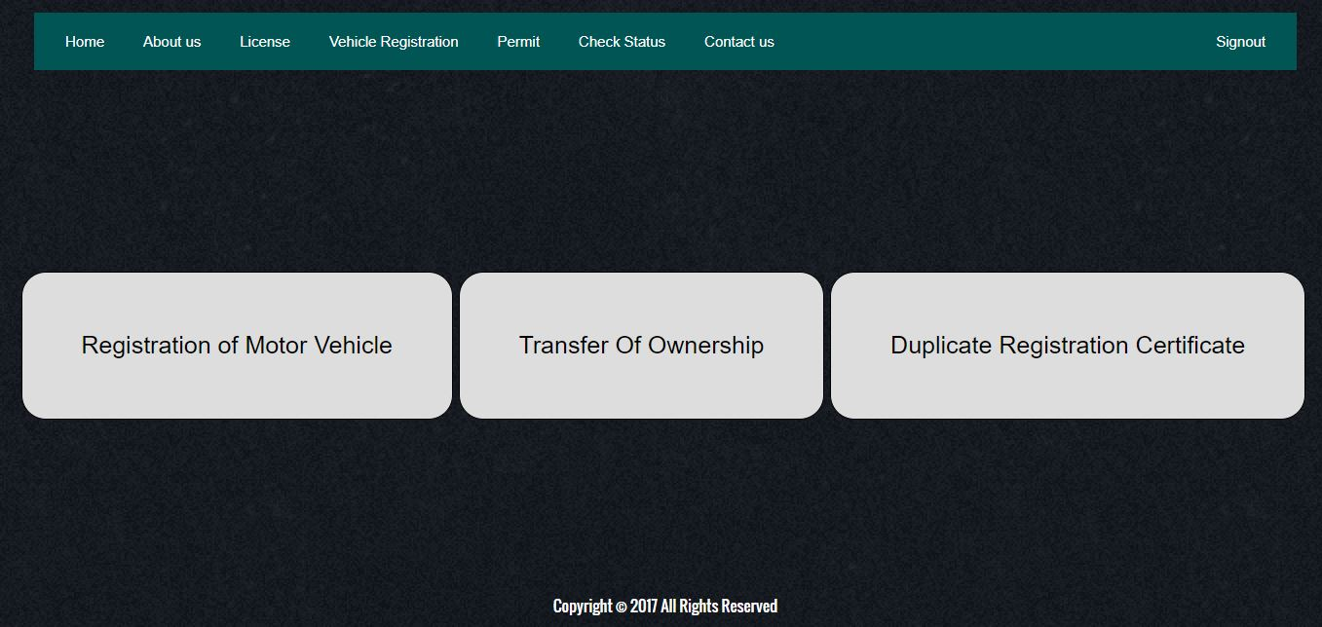

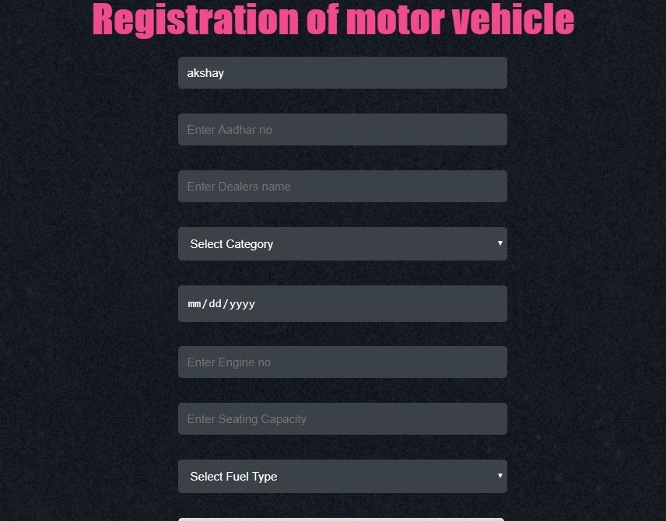

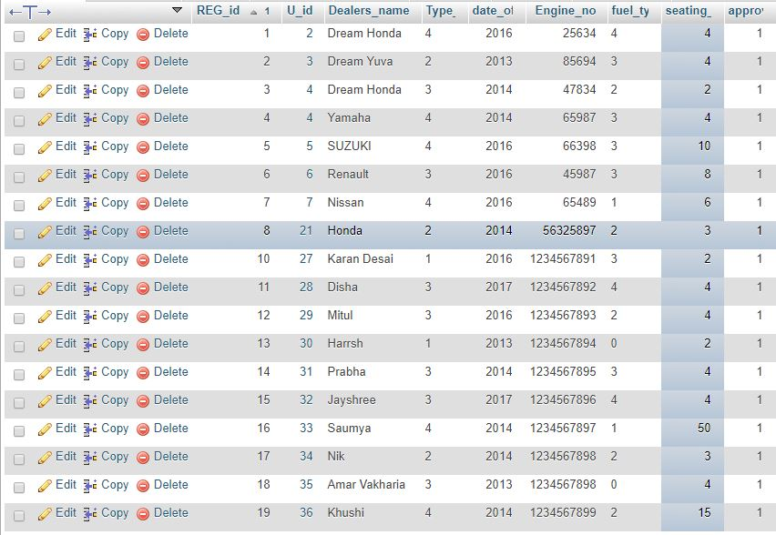

-----------------------------------------------------------------------------------------------------------------------------------

----------------------------**FOR TABLE REG_MOTOR_VEHICLE_RESULT**--------------------------

INSERT INTO `reg_motor_result` (`REG_id`, `reg_no`, `dl_no`, `U_id`, `Engine_no`, `A_id`) VALUES

(1, 'RG59feb18f5b868', 'DL59we45161fd9d', 2, 25634, 20),

(2, 'RG60jna2c29047d', 'DL56ty76161fd9d', 3, 85694, 20),

(3, 'RG61mab2c29047', 'DL637818161fd9d', 4, 47834, 20),

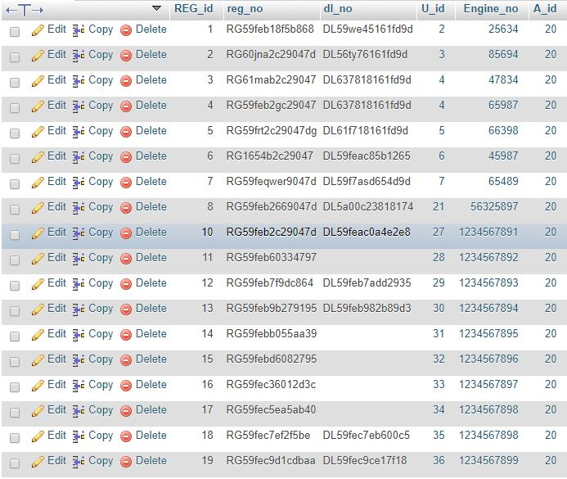-----------------------------------------------------------------------------------------------------------------------------------

------------------------------------------------**FOR TABLE PERMIT**------------------------------------------------

Some vehicles like the ones used for transportation of national goods or school bus/rickshaw/cab/taxi needs a govt. permit. By filling up and submitting the below form one and apply for the permit.

INSERT INTO `permit` (`P_id`, `type_of_permit`, `REG_id`, `reg_no`, `U_id`, `approval_status`) VALUES

(1, '4', 2, 'RG60jna2c29047d', 2, 1),

(2, '2', 3, 'RG61mab2c29047', 3, 1),

(3, '3', 4, 'RG59feb2gc29047', 4, 1),

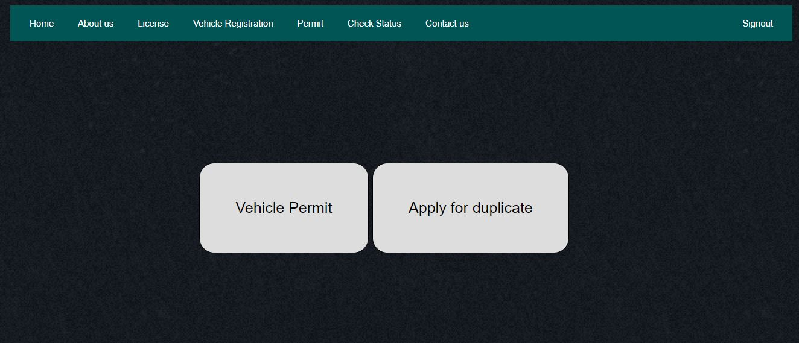

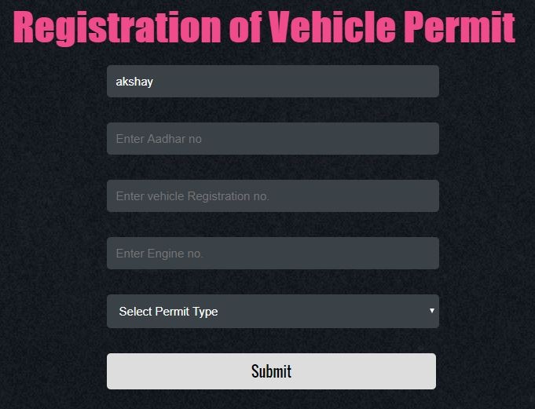

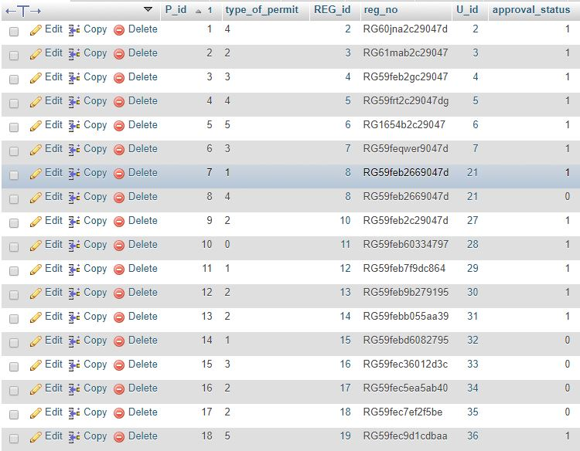

-----------------------------------------------------------------------------------------------------------------------------------

---------------------------------------**FOR TABLE PERMIT_RESULT**-----------------------------------------

INSERT INTO `permit_result` (`P_id`, `U_id`, `reg_no`, `Engine_no`, `p_no`, `A_id`) VALUES

(1, 2, 'RG60jna2c29047d', 85694, 'PR5a00d644362ef', 20),

(2, 3, 'RG61mab2c29047', 47834, 'PR5a00d645110cc', 20),

(3, 4, 'RG59feb2gc29047', 65987, 'PR5a00d645e20fa', 20),

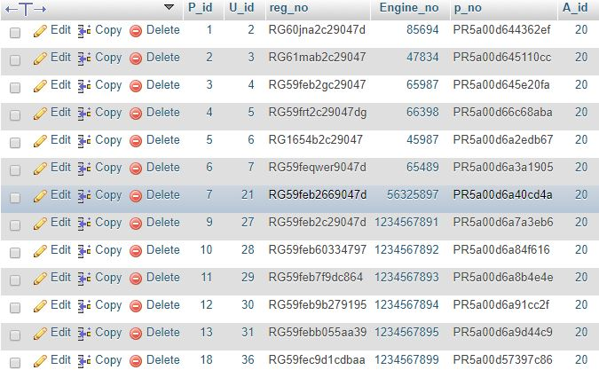

-----------------------------------------------------------------------------------------------------------------------------------

------------------------------**FOR TABLE TRANSFER OF OWNERSHIP**--------------------------------

INSERT INTO `transfer of ownership` (`T_id`, `S_U_id`, `R_U_id`, `REG_id`, `approval_status`) VALUES

(1, 4, 2, 4, 1),

(3, 2, 4, 2, 1),

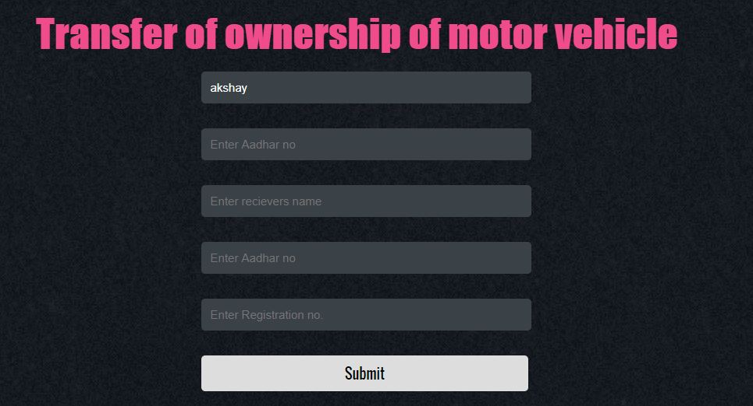

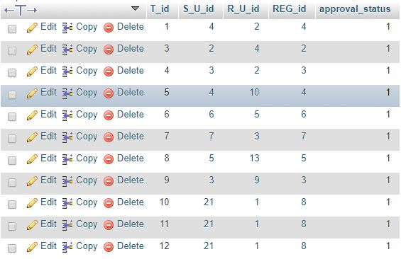

-----------------------------------------------------------------------------------------------------------------------------------

---------------------------------------**FOR TABLE TRANSFER PROCESS**---------------------------------

INSERT INTO `transfer_process` (`T_id`, `REG_id`, `A_id`) VALUES

(4, 3, 20),

(7, 7, 20),

(8, 5, 20),

(9, 3, 20),

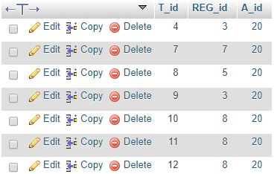

-----------------------------------------------------------------------------------------------------------------------------------

-----------------------------**FOR TABLE RENEWAL OF DRIVING LICENSE**-------------------------

INSERT INTO `renenwal_of_dl` (`REN_id`, `dl_no`, `U_id`, `date_of_issue`, `date_of_expiry`, `date_of_last_renewal`, `approval_status`) VALUES

(1, 'DL59f7181618956', 1, '2013-09-04', 24, '2015-09-04', 1),

(2, 'DL59we45161fd9d', 2, '2013-09-07', 24, '2015-09-25', 1),

(3, 'DL56ty76161fd9d', 3, '2013-09-04', 24, '2015-09-01', 1),

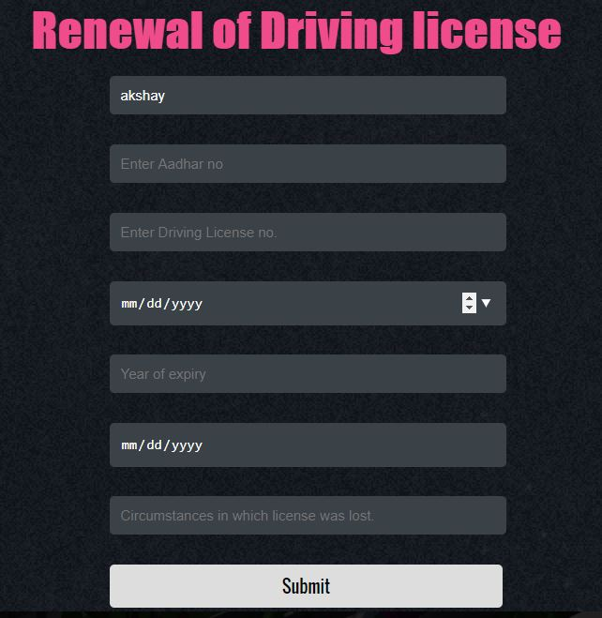

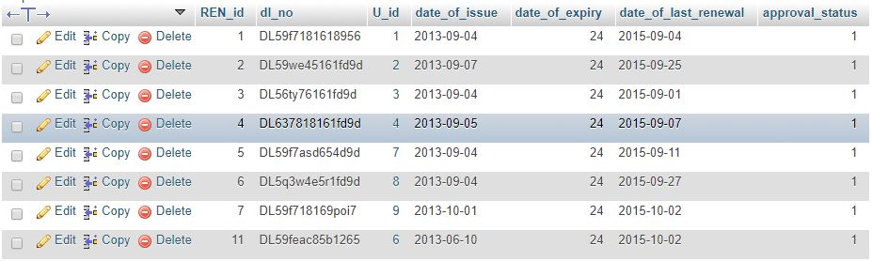

-----------------------------------------------------------------------------------------------------------------------------------

--------------------------------**FOR TABLE RENEWAL OF DL RESULT**---------------------------------

INSERT INTO `renewal_dl_result` (`REN_id`, `D_id`, `dl_no`, `A_id`) VALUES

(1, 1, 'DL59f7181618956', 20),

(2, 2, 'DL59we45161fd9d', 18),

(3, 3, 'DL56ty76161fd9d', 20),

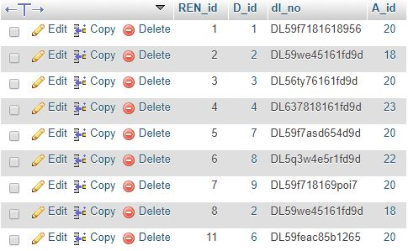

-----------------------------------------------------------------------------------------------------------------------------------

-------------------------------------**FOR TABLE DUPLICATE LICENSE**------------------------------------

INSERT INTO `duplicate license` (`DUP_id`, `dl_no`, `Circumstances`, `previously_applied`, `approval_status`) VALUES

(1, 'DL59f7181618956', 'lost in floods', 0, 1),

(2, 'DL59we45161fd9d', 'stolen', 0, 1),

(3, 'DL56ty76161fd9d', 'lost in wallet', 0, 1),

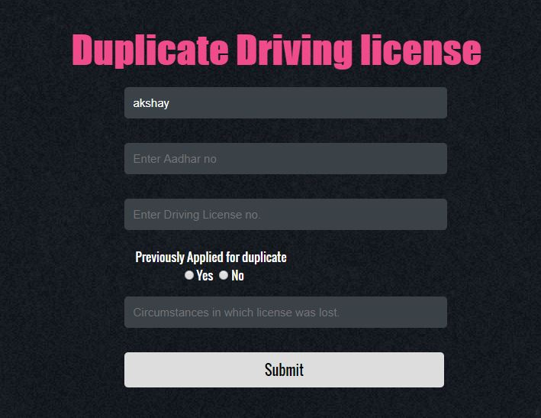

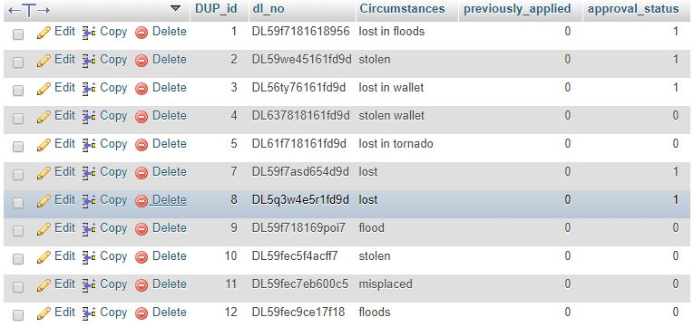-----------------------------------------------------------------------------------------------------------------------------------

-------------------------------**FOR TABLE DUPLICATE LICENSE RESULT**---------------------------

INSERT INTO `duplicatelicense_result` (`DUP_id`, `D_id`, `dl_no`, `A_id`) VALUES

(1, 2, 'DL59we45161fd9d', 20),

(2, 3, 'DL56ty76161fd9d', 20),

(3, 7, 'DL59f7asd654d9d', 20),

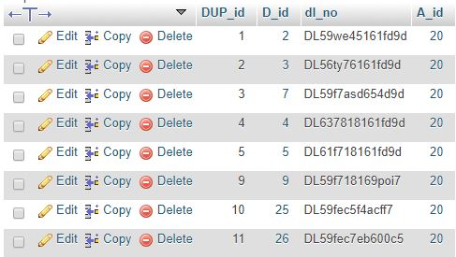

-----------------------------------------------------------------------------------------------------------------------------------

--------------------------------------**FOR TABLE DUPLICATE PERMIT**-------------------------------------

INSERT INTO `duplicate permit` (`DUP_P_id`, `P_id`, `p_no`, `Circumstances`, `approval_status`) VALUES

(1, 1, '', 'lost in floods', 1),

(2, 2, '', 'lost somewhere I dont know where', 1),

(3, 3, '', 'stolen', 1),

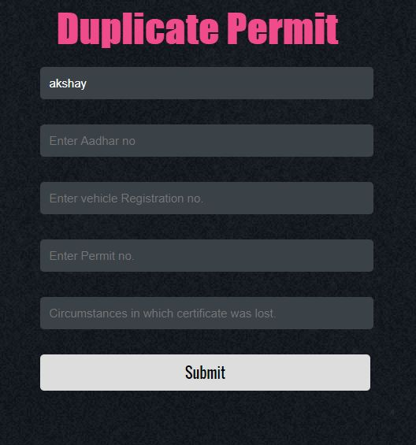

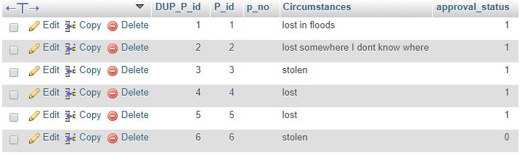

-----------------------------------------------------------------------------------------------------------------------------------

-------------------------------**FOR TABLE DUPLICATE PERMIT RESULT**-----------------------------

INSERT INTO `duplicate_permit_result` (`DUP_id`, `P_id`, `p_no`, `A_id`) VALUES

(1, 1, 'PR5a00d644362ef', 20),

(2, 2, 'PR5a00d645110cc', 20),

(3, 3, 'PR5a00d645e20fa', 20),

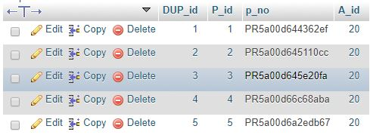

-----------------------------------------------------------------------------------------------------------------------------------

-----------------------------**FOR TABLE DUPLICATE REG CERTIFICATE**----------------------------

INSERT INTO `duplicate reg certificate` (`DUP_REG_id`, `REG_id`, `circumstances`, `approval_status`) VALUES

(1, 2, 'misplaced', 1),

(2, 3, 'stolen', 1),

(3, 4, 'lost', 1),

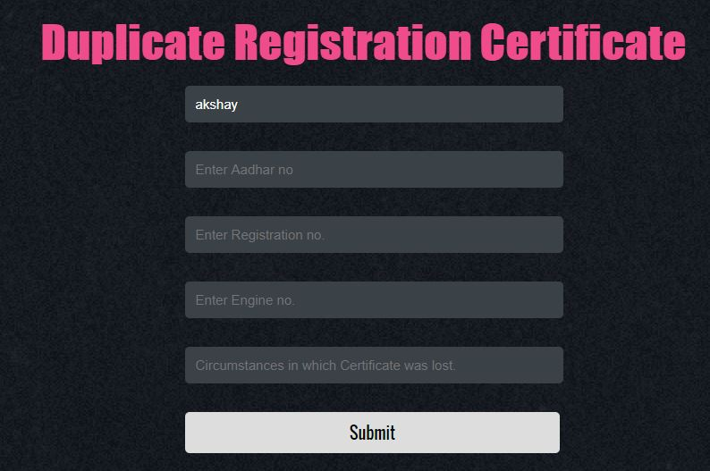

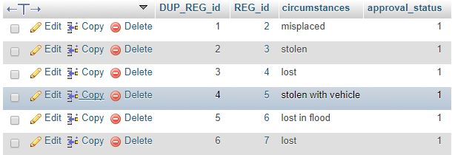

-----------------------------------------------------------------------------------------------------------------------------------

---------------------------------**FOR TABLE DUPLICATE REG RESULT**---------------------------------

INSERT INTO `duplicate_reg_result` (`DUP_REG_id`, `REG_id`, `reg_no`, `Engine_no`, `A_id`) VALUES

(1, 2, 'RG60jna2c29047d', 85694, 20),

(2, 3, 'RG61mab2c29047', 47834, 20),

(3, 4, 'RG59feb2gc29047', 65987, 20),

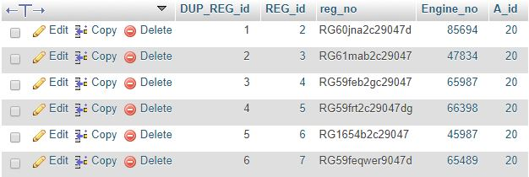

-----------------------------------------------------------------------------------------------------------------------------------

----------------------------------------------------**FOR TABLE USER**------------------------------------------------

INSERT INTO `user` (`U_id`, `Name`, `email`, `Address`, `Aadharno`, `Gender`, `Contact`) VALUES

(1, 'Harsh', 'hrsshah21@gmail.com', 'Sumeru Heights', 846013585912, 0, 8866780373),

(2, 'Himanshu', 'himanshu@gmail.com', 'Sumeru Heights', 932841242812, 0, 9328412428),

(3, 'Milind', ',ilind@gmail.com',umeru Heights', 846013565412, 0, 9638527412),

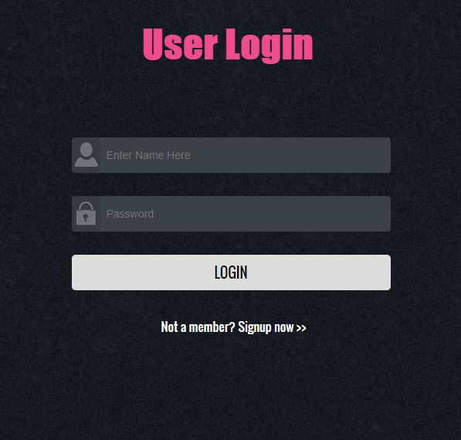

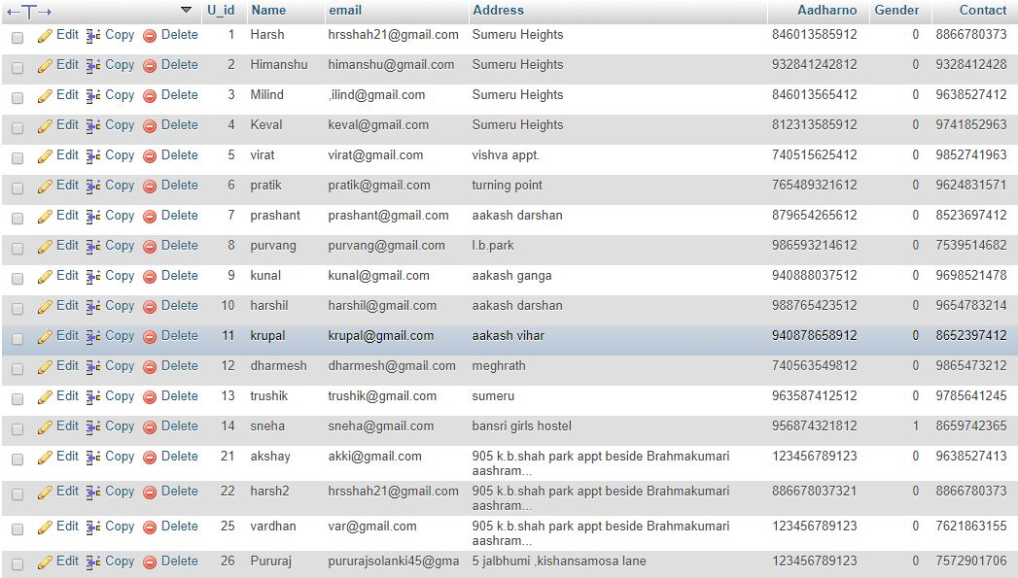

-----------------------------------------------------------------------------------------------------------------------------------

-------------------------------------------**FOR CHECKING STATUS**----------------------------------------------

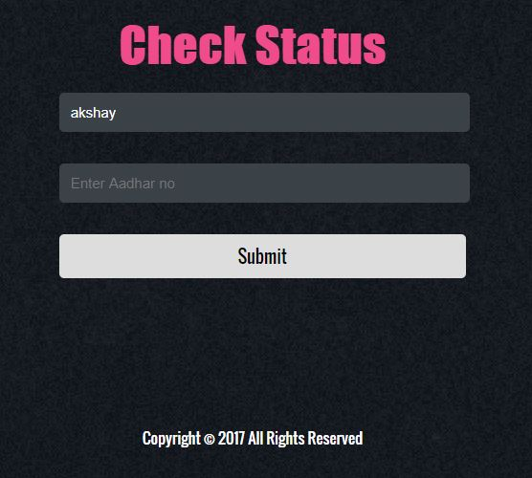

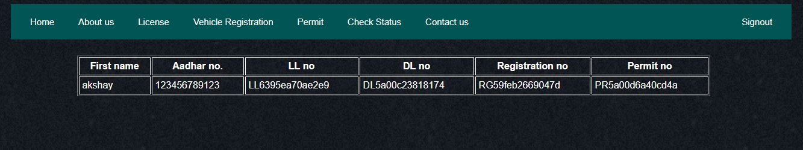

*FRONT END FOR ADMIN SIDE*

-----------------------------------------**FOR TABLE AUTHORITY**------------------------------------------------

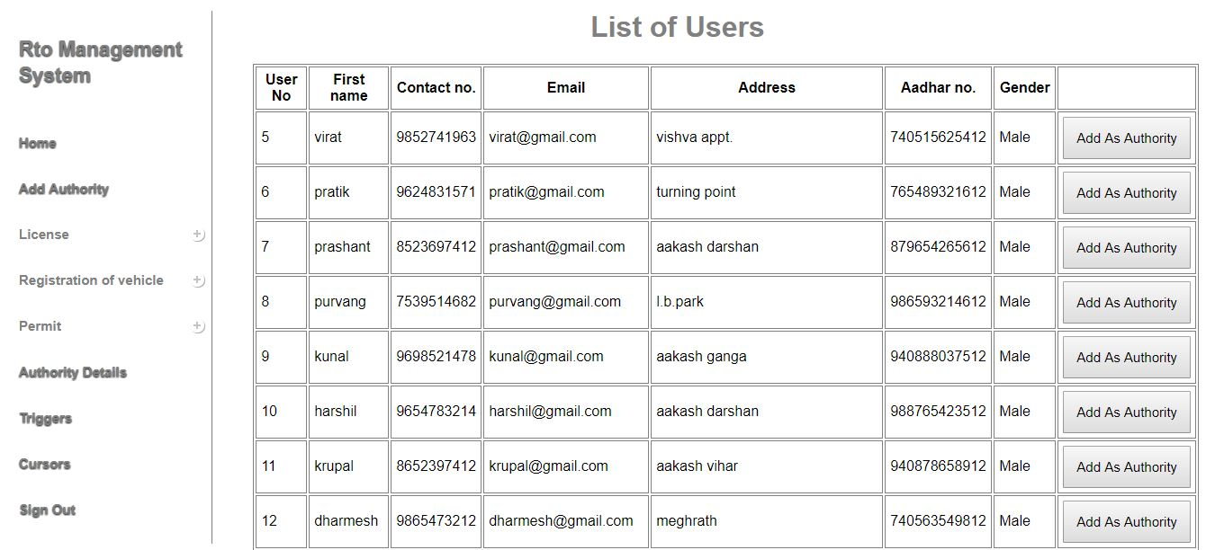

-----------------------------------------------------------------------------------------------------------------------------------

-----------------------------------------------**FOR TABLE DETAILS**------------------------------------------------

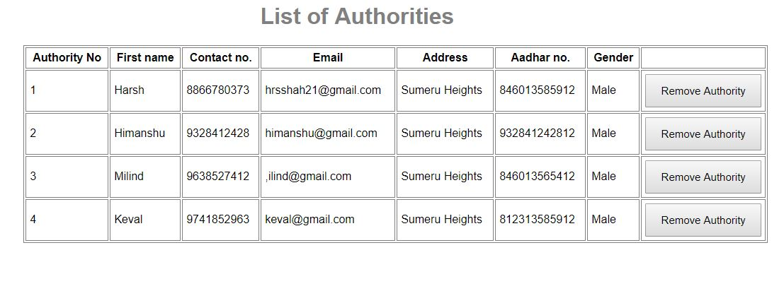-----------------------------------------------------------------------------------------------------------------------------------

------------------------------------**FOR TABLE DRIVING LICENSE**-------------------------------------------

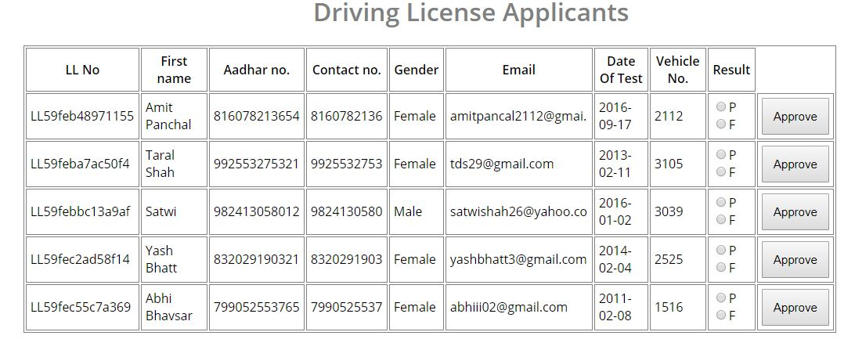

-----------------------------------------------------------------------------------------------------------------------------------

----------------------------**FOR TABLE DUPLICATE DRIVING LICENSE**------------------------------

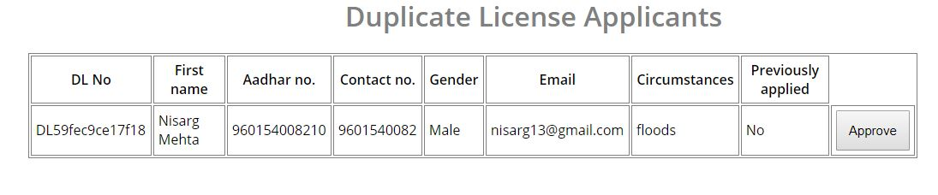

-----------------------------------------------------------------------------------------------------------------------------------

------------------------------------**FOR TABLE NEW REGISTRATION**--------------------------------------

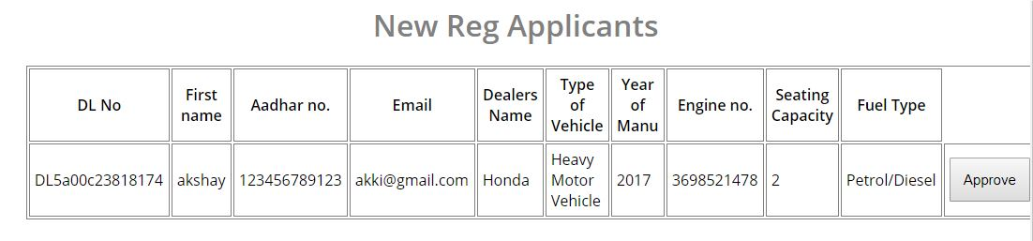

-----------------------------------------------------------------------------------------------------------------------------------

---------------------------------**FOR TABLE DUPLICATE REGISTRAION**-------------------------------

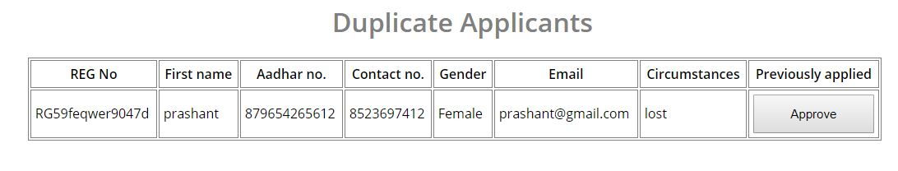

-----------------------------------------------------------------------------------------------------------------------------------

-------------------------------------------**FOR TABLE PERMIT**-----------------------------------------------------

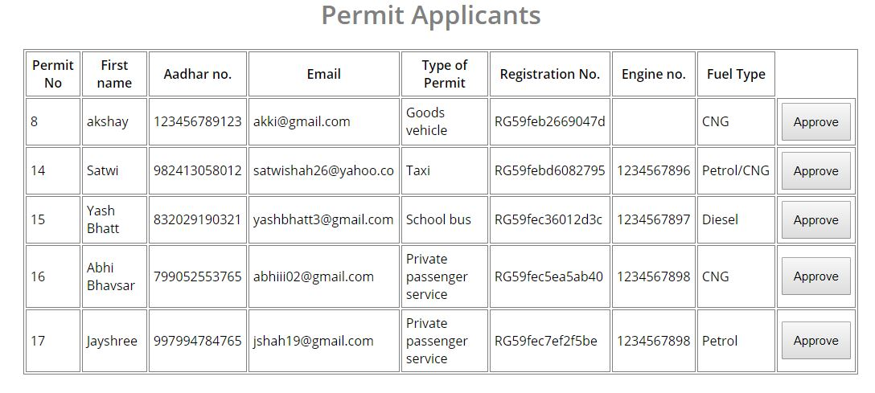

-----------------------------------------------------------------------------------------------------------------------------------

---------------------------------**FOR TABLE DUPLICATE PERMIT**------------------------------------------

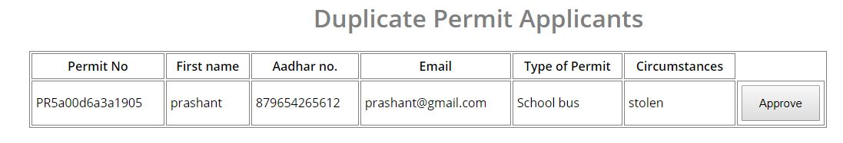

-----------------------------------------------------------------------------------------------------------------------------------

--------------------------------**FOR TABLE TRANSFER OF OWNERSHIP**------------------------------

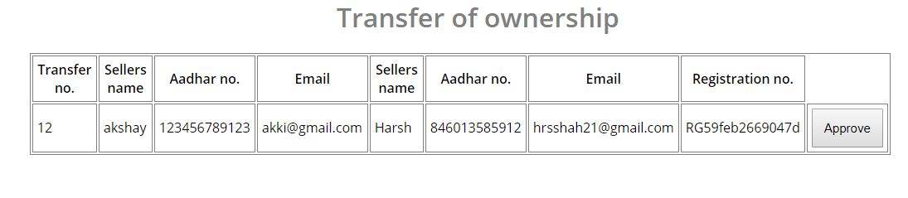

-----------------------------------------------------------------------------------------------------------------------------------

------------------------------------**FOR TABLE LEARNING LICENSE**---------------------------------------

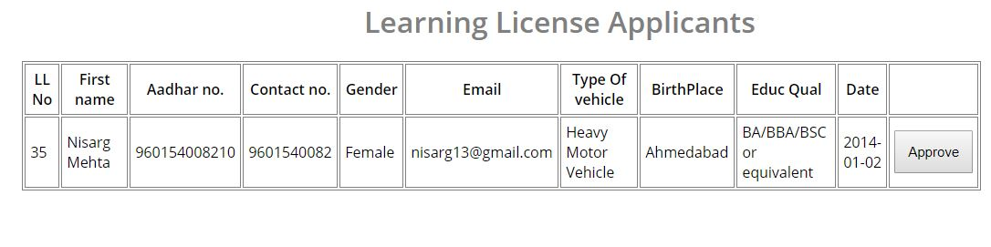

-----------------------------------------------------------------------------------------------------------------------------------

---------------------------**FOR TABLE RENEWAL OF DRIVING LICENSE**---------------------------

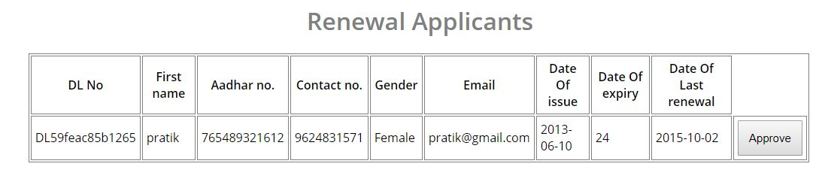

-----------------------------------------------------------------------------------------------------------------------------------

---------------------------------------**FOR DIPLAYING USER DETAILS**--------------------------------------

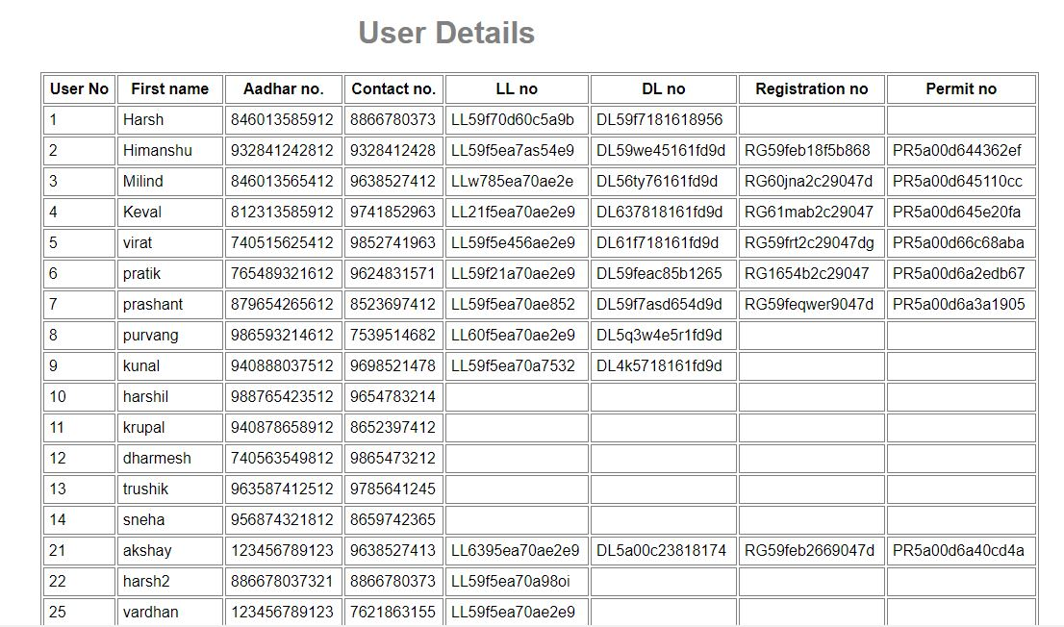

-----------------------------------------------------------------------------------------------------------------------------------

*TRIGGERS*

-------------------**TRIGGER FOR ADMIN GRANTS PERMISSION TO USER** -------------------

When approve button is clicked this trigger runs after insert on `result` table. Whenever a user requests for certain functionality his/her data entry is done in the respective table. Now when authority grants the permission to the user by selecting ‘approve’ trigger is generated and access value which was inserted in result table is updated in main table. Only when approval status in main table is set to ‘1’ i.e. authority approves the request of the user.

PHP CODE USED FOR TRIGGER IN DUPLICATE LICENSE

<?php

$sql4 = "DROP TRIGGER IF EXISTS `dup_license1`;";

$res4 = mysql_query($sql4);

$sql1 = "CREATE TRIGGER `dup_license1` AFTER INSERT ON `duplicatelicense_result` FOR EACH ROW UPDATE `duplicate license` SET `approval_status`= 1 WHERE `DUP_id` = $_POST[dup_id]";

$result1 = mysql_query($sql1);

echo $sql3 = "INSERT INTO `duplicatelicense_result`(`DUP_id`, `D_id`,`dl_no`, `A_id`) VALUES ('$dup_id','$dl_id','$dl_no','$aid')";

$result3 = mysql_query($sql3);

if($result3)

{

header("location:duplicateLicense.php");

}

else

{

echo "Server Error";

}?>

The approval status is 0 for non-granted requests and 1 for the granted ones.



PHP CODE USED FOR TRIGGER IN DUPLICATE LICENSE

<?php

$sql4 = "DROP TRIGGER IF EXISTS `new_per_trigger`;";

$res4 = mysql_query($sql4);

$sql5 = "CREATE TRIGGER `new_per_trigger` AFTER INSERT ON `permit_result` FOR EACH ROW UPDATE `permit` SET `approval_status`=1 WHERE `P_id` = '$p_id'";

$result5 = mysql_query($sql5);

$sql4 = "INSERT INTO `permit_result`(`P_id`, `U_id`, `reg_no`, `Engine_no`, `p_no`, `A_id`) VALUES('$p_id','$u_id','$reg_no','$engine_no','$p_no','$aid')";

$result4 = mysql_query($sql4);

if($result4)

{

header("location:vehicle_permit.php");

}

else

{

echo "Server Error";

}

?>

The approval status is 0 for non-granted requests and 1 for the granted ones.



**BIBLIOGRAPHY**

* **Reference books:**
* **SQL, MYSQL The programming language of PHP**
* **Reference Link:**
* www.w3schools.com/
* <https://stackoverflow.com/>

* [www.google.com/](http://www.google.com/)
* [www.vahan.nic.in](http://www.vahan.nic.in)
* www.saarthi.nic.in